How to reach the EC2 Instance:

Save the file itec414.ppk that is in the files somewhere locally.

Install Putty if you haven’t before.

Fill out the first screen as follows:  
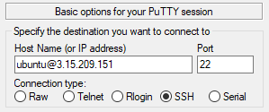  
“ ubuntu@3.15.209.151 “

Go to Connection>SSH>Auth  
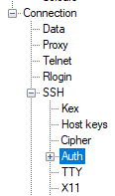

Click browse and select itec414.ppk that you saved earlier.

Click Open and Click Yes.